Threat Intelligence Report
Organization: National CERT
Group: Sea Turtle Threat Group
Analyst: Onaopemipo David Olugbemiro
Date: October, 2025

Executive Summary
This report documents the investigation of the Sea Turtle threat actor group based on data extracted from the MISP threat intelligence platform. Sea Turtle, a Turkish-linked espionage group, has conducted multiple DNS hijacking and credential theft operations against government and critical infrastructure targets in Europe. By analyzing Indicators of Compromise (IOCs) and mapping them to MITRE ATT&CK, this report reveals how Sea Turtle leverages VPN-based access, malicious C2 servers, and rented hosting infrastructure to mask its operations. The findings provide actionable recommendations to improve detection, mitigation, and defense strategies for National CERT and partner organizations.

Table of content
- Introduction
- Project Objective
- Investigation Method
- Findings
- Mitigation & Recommendation
- Conclusion
- Reference
- Appendix

1. Introduction
This report provides an in-depth analysis of a sophisticated espionage group known as Sea Turtle, also referred to as Teal Kurma or Marbled Dust. This threat actor has been active since at least 2017 and has primarily targeted governmental, telecommunications, and critical infrastructure organizations across Europe and the Middle East. The group is associated with state-sponsored campaigns focused on credential theft, DNS hijacking, and persistent access to registrar systems.
This report documents the investigation process using real-world intelligence feeds obtained from the MISP platform, which helped identify Indicators of Compromise (IOCs), attack infrastructure, and mapped observed behaviors to the MITRE ATT&CK framework. The intelligence gathered provides actionable recommendations for defensive measures that can be adopted by National CERTs.

2. Project Objective
The main objective of this project is to investigate the Sea Turtle threat actor using threat intelligence data extracted from MISP. The analysis aims to uncover their attack infrastructure, identify key indicators of compromise, and align their tactics, techniques, and procedures (TTPs) with the MITRE ATT&CK framework. The goal is to produce a comprehensive threat profile that supports early detection and mitigation of potential Sea Turtle activities.
3. Investigative Method
To gather essential intelligence on the threat actor group, the cybersecurity threat intelligence team used Docker Compose to deploy live threat feeds from MISP in a containerized environment on Kali Linux. The active feeds and event lists in MISP provided unique UUIDs linked to each threat actor, offering detailed information needed to profile their tactics, infrastructure, and possible involvement in specific attacks. This setup allowed the team to analyze and attribute threat activities using real-time intelligence.
Additionally, the MISP event feed data was cross-referenced with the MITRE ATT&CK framework to uncover deeper insights into the Sea Turtle threat actor's tactics, techniques, and procedures (TTPs). Furthermore, research reports from Cisco Talos provided critical details vital for detecting, containing, and neutralizing these threats.

4. Findings
The metadata below was retrieved from the MISP events list, offering key insights into the threat actor in question. Sea Turtle is a state-sponsored threat group linked to Turkey, active since 2017. It conducts espionage and compromises service providers, targeting governments, military agencies, energy infrastructure, telecom companies, and more across the Middle East, North Africa, Europe, and other regions. The group specializes in DNS hijacking, including attacks on registrars for country-code top-level domains (ccTLDs) and complex DNS intrusions. In these operations, they infiltrate DNS providers to manipulate resolution paths for end victims, enabling them to impersonate login pages and applications for credential theft.
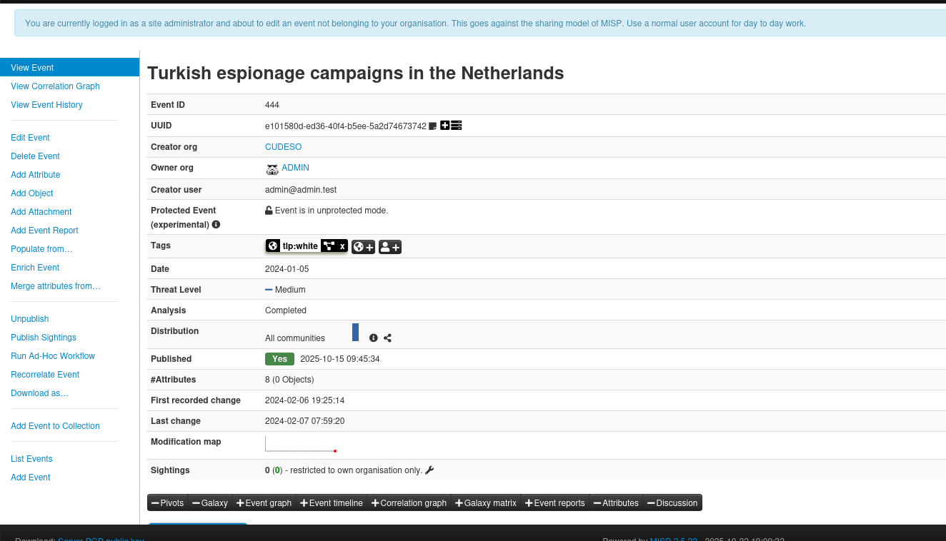
IOC enrichment revealed that Sea Turtle’s infrastructure is heavily reliant on commercial VPN and hosting providers across Europe. These include M247 (Belgium), Arelion (Denmark), Snel.com (Netherlands), and Vultr (Germany). This approach allows Sea Turtle to obfuscate attribution by blending malicious activity with legitimate internet traffic.

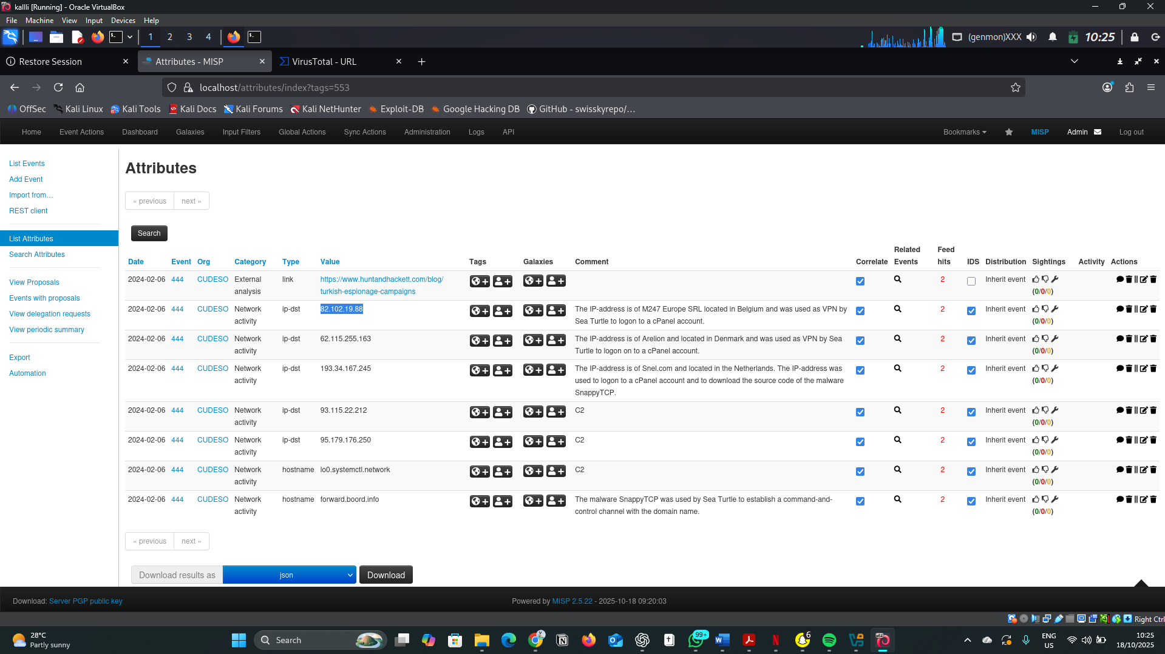

4.2. Indicator of compromise (IOCs)
IOC | ASN | Org / Hosting | Country | Notes | Confidence
82.102.19.88 | AS9009 | M247 Europe SRL | Belgium | VPN infra; flagged by security vendors; used for login access | Medium
62.115.255.163 | AS1299 | Arelion Sweden AB | Denmark | Carrier VPN; reused in multiple campaigns | Medium
193.34.167.245 | AS62370 | Snel.com BV | Netherlands | Used for SnappyTCP malware download | High
93.115.22.212 | AS202448 | MVPS LTD | Netherlands | Explicitly tagged C2 server | High
95.179.176.250 | AS20473 | Vultr Holdings | Netherlands | Dedicated C2 infrastructure | High
lo0.systemctl.network |  | Localhost (artifact) |  | Likely decoy or beacon string in malware | Low
forward.boord.info |  | Cloudflare | US | Domain used for SnappyTCP C2 communication | High

4.3. Threat Actor Profile
Group Name: Sea Turtle (a.k.a. Teal Kurma, Marbled Dust)
Origin: Turkey
Motivation: Espionage and state-aligned intelligence gathering
First Observed: 2017
Primary Targets: Government, telecom, energy, and DNS infrastructure across Europe and the Middle East
Tactics Used: DNS hijacking, credential theft, C2 over HTTPS, persistence via registrar compromise
Known Malware / Tools: SnappyTCP (custom reverse shell), DNS manipulation scripts
Notable Campaigns: Cisco Talos (2019), Tenable (2021), Hunt & Hackett (2024)

4.5. Techniques Used (MITRE TTP Mapping)
Tactic | Technique | Technique ID | Evidence | Detection
Reconnaissance | Acquire Infrastructure | T1583 | VPN access from commercial hosting | Track new domains/IPs linked to cloud providers
Initial Access | Valid Accounts | T1078 | VPN logins to compromised registrar accounts | Monitor logins from M247, Arelion ASN ranges
Credential Access | Credential Dumping | T1003 | Capturing credentials via hijacked DNS portals | Enable MFA and credential reuse alerts
Persistence | Modify Authentication Process | T1556 | Hijacking DNS login portals | Monitor cPanel and DNS configuration integrity
Command & Control | Application Layer Protocol: Web | T1071.001 | C2 via forward.boord.info over HTTPS | Detect outbound HTTPS to untrusted domains
Defense Evasion | Use of Commercial Hosting | T1583.003 | C2 hosted on M247, Vultr, Serverius | Alert on traffic to known hosting ASN ranges
Execution | Command and Scripting Interpreter | T1059 | Use of shell commands in SnappyTCP | Suspicious command execution
Impact | DNS Hijack / Defacement | T1565.002 | DNS redirection of registrar records | Enforce registry lock; monitor DNS zone changes

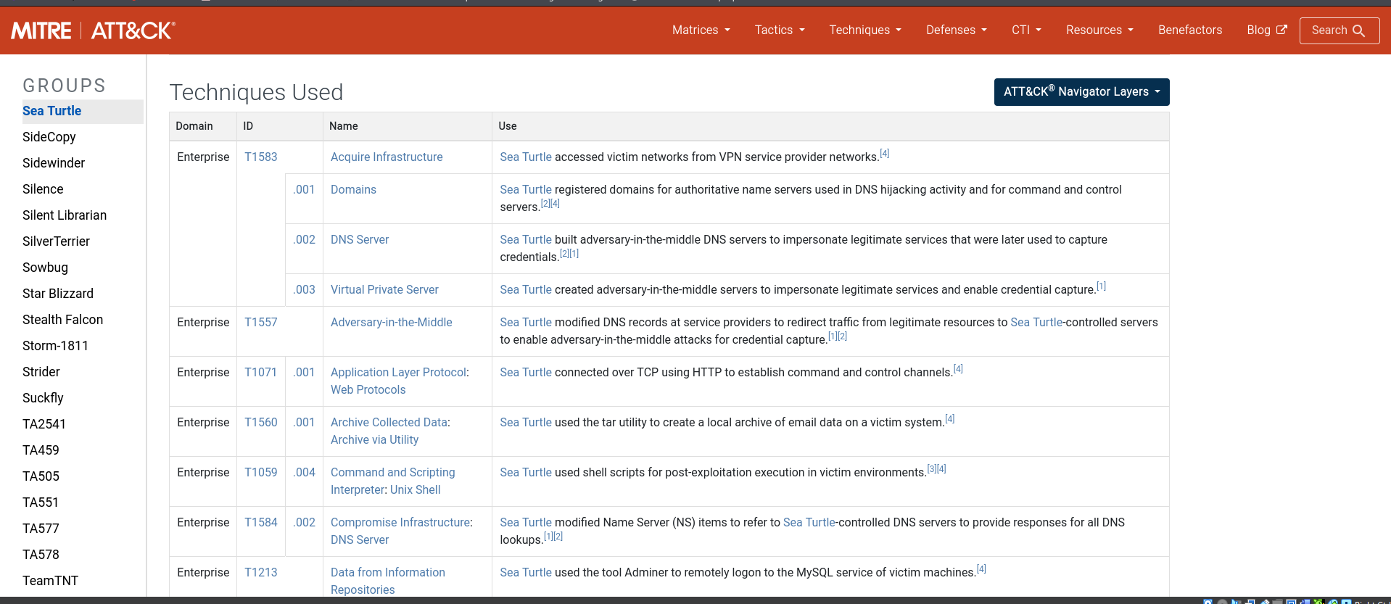

5. Mitigations & Recommendations
- Enable registry lock, enforce MFA, restrict registrar logins. To avoid risk of DNS hijacking.
- Block IOCs (IPs/domains) via firewall and IDS signatures.
- Monitor DNS Changes and Certificate Issuance
- Integrate Threat Feeds and Enrichment Tools. Use MISP, VirusTotal, and ThreatFox feeds to track IOCs and stay updated on actor activity.
- Implement DNSSEC (Domain Name System Security Extensions)

6. Conclusion
The investigation into the Sea Turtle threat actor highlights a sophisticated and persistent espionage operation leveraging DNS hijacking and credential theft. By exploiting registrar accounts and abusing commercial hosting services, Sea Turtle conceals its infrastructure behind legitimate providers. Organizations can mitigate such threats by adopting proactive detection mechanisms, enforcing MFA, and monitoring DNS zone integrity.
Their campaigns are typically stealthy, long-term, and strategically targeted. Without proper defenses, organizations risk data breaches, credential loss, and service disruption. The implementation of DNSSEC, threat monitoring, and credential protection is critical.

7. References
- Hunt & Hackett. (2024). Turkish Espionage Campaigns. https://www.huntandhackett.com/blog/turkish-espionage-campaigns
- Cisco Talos. (2019). Global DNS Hijacking Campaign.
- Tenable. (2021). Sea Turtle: Persistent DNS Hijacking Threat.
- MITRE ATT&CK Framework (v14). https://attack.mitre.org
- VirusTotal & RIPE NCC ASN lookups

8. Appendix

